Manuscript Preparation Guidelines for the Rajamangala Manufacturing and Management Technology Conference
(1 line spacing with font size 14)
Kaona Jonguwuttanaruk¹ Thiti Mhoraksa² and Ponlapath Tipboonsri^{1*}
¹Department of Industrial Engineering, Faculty of Engineering,
Rajamangala University of Technology Thanyaburi
²Department of Industrial Engineering, Faculty of Integrated Engineering and Technology,
Rajamangala University of Technology Tawan-Ok, Chanthaburi Campus
Corresponding author E-mail: ponlapath.t@en.rmutt.ac.th*
(1 line spacing with font size 14)
(1 line spacing with font size 14)

Abstract
An abstract should not exceed 400 words or 20 lines. The words "Abstract" and “Keyword:” are in 14 pt. bold of TH Sarabun New font. The body of the abstract is in 14 pt. normal of TH Sarabun New font with single-spaced. It should be an explicit summary of your presentation that states the problem, the methods, the major results, and the conclusion. For the keyword, you should not use more than 5 keywords and separate each keyword with a comma “,”.
Keywords: 3-5 words, 14-Point, Normal of TH Sarabun New
(1 line spacing with font size 14)

1. Introduction
The introduction shows the background of the problem, the objective of the research, and the literature review of the problem.
This RMTC template shows a layout for preparing your manuscript.
(1 line spacing with font size 14)
2. Paper format
The manuscript contains an article title, address, and e-mail of the corresponding author. Valuable reviewed articles and translated texts are also acceptable. Each manuscript including an abstract and reference must be 4-6 pages long.

2.1 Paper size and layout
Your manuscript should be formatted for an A4- sized paper (21.0 cm x 29.7 cm) written in 2 columns. Columns are 77 mm wide, with 6 mm separation between them. Left and right margins are 25 mm each. The top and bottom margins are 25 mm each. Each indent should be set at 7.5 mm. Leave a blank line before the section heading but not for the subsection heading.
2.2 Styles and Fonts
For the English version, TH Sarabun New font must be used. The article title should not be long and it must be in boldface 18 points of TH Sarabun New font 14 points must be used for all authors’ full names with number 1,2,3 at the end of each full name.
Bold 14 points is recommended for the section heading and the subsection heading. For the main body of the document, use normal 14 points. If you use Microsoft Word to prepare your manuscript, you can use this template.
(1 line spacing with font size 14)
3. Research results
The research results should be presented clearly and to the point. Figures and/or tables should not be duplicated.
3.1 Numbering
Use Arabic numerals for figures, tables, and equations. Every equation must be numbered in parentheses and the equation number should be aligned with the right edge of the column. (as shown in an example below)
(1 line spacing with font size 14)
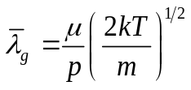 (1)
(1 line spacing with font size 14)
10-points Times New Roman is used for equations. MathType or Equation Editor should be used for writing an equation.
Units are written using the SI system. For references, use Arabic numerals in square brackets. (as shown in the References section)
3.2. Figures and tables
The figures and tables must appear in one column. If it is necessary, they may span the two columns.
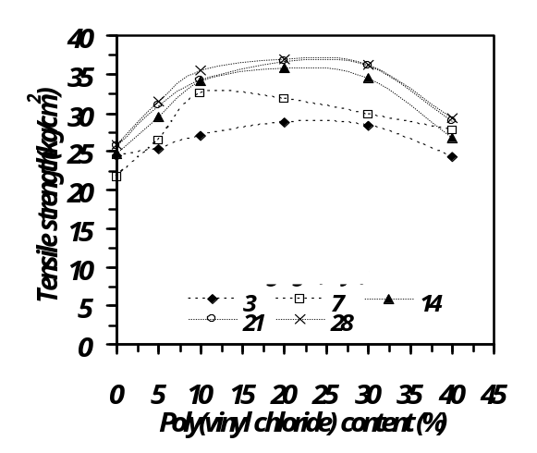
Figure 1 An Example of a Clearly Visible Graph
(1 line spacing with font size 14)
Details in the figures must be seen clearly. All figures and tables must be numbered together with their captions.
Lines must be in black using Visio, Adobe Illustrator, Macromedia Freehand, or other drawing programs to create them. Photos should be sharp in black and white. Figures should be as detailed as necessary.
All figures must be numbered and closed captions. They are listed in the order they appear from 1, 2, 3,…. Each figure must be centered. Leave a blank line before each figure and after its caption.
For tables, their captions must be placed above the tables in the order that they appear from 1, 2, 3,…. Each table must be aligned with the left edge of the column. Leave a blank line before the table caption and after the table.

Table 1 Creating Tables (14-point TH Sarabun New)
 | 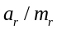 | 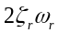
0.2 | 3.6470e+01 | 4.7483e+01
0.9 | 6.7352e+01 | 7.7360e+01
0.2 | 3.6470e+01 | 4.7483e+01
0.9 | 6.7352e+01 | 7.7360e+01
0.2 | 3.6470e+01 | 4.7483e+01
0.9 | 6.7352e+01 | 7.7360e+01
0.2 | 3.6470e+01 | 4.7483e+01
0.9 | 6.7352e+01 | 7.7360e+01
0.2 | 3.6470e+01 | 4.7483e+01
0.9 | 6.7352e+01 | 7.7360e+01
(1 line spacing with font size 14)
4. Discussion
Provide a discussion of your findings, compare them with the research results of others, offer means to use your findings or to solve some problems. Results of research and discussion may be written in the same section.
(1 line spacing with font size 14)
5. Conclusion
Your article should be reviewed by all co-authors before submitting it.
(1 line spacing with font size 14)
6. Acknowledgments
This research was supported by Research and Development Institute Rajamangala University of Technology……...
(1 line spacing with font size 14)
7. References
Authors submitting their work to The 11th Rajamangala Manufacturing and Management Technology Conference (RMTC2026) are highly encouraged to consider citing relevant articles from The Journal of Manufacturing and Management Technology to enhance the academic integration of their research. https://ph01.tci-thaijo.org/index.php
/jMMT/. The reference section should appear at the end of the manuscript. All references must be listed in the order that are cited in the manuscript. Please follow the example below.
- Barrat, J.L. and Bocquet, L., “Large Slip Effect at Nonwetting Fluid-Solid Interface”, Physical Review Letters, 82: (1999), pp. 4671-4674.
- Kalasee, W., Tekasakul, S., Otani, Y. and Tekasakul, P. “Characteristics of soot particles produced from rubber wood combustion”, Proceedings of the Second Asian Particle Technology Symposium, Penang, Malaysia, Dec. 17-19, 2003: (2003), pp. 103-108.
- Bhadpiroon Sresomroeng, Pakorn Chumrum, Jiraporn Sripraserd and Varunee Premanond, “Sidewall-curl prediction in U-bending process of advanced high strength steel”, The Second TSME International Conference on Mechanical Engineering, 19-21 October, 2011, Krabi, Thailand, (2011), pp. 150-158.
- B. Sresomroeng, V. Premanond, P. Kaewtatip, A. Khantachawana, A. Kurosawa, N. Koga, “Performance of CrN radical nitrided tools on deep drawing of advanced high strength steel”, Surface & Coatings Technology, Vol.205, (2011), pp.4198–4204.
- SONG Ruoyuan, INO Haruhiro and KIMURA Teruo, “Mechanical Property of Silk/Bamboo Composite Paper for Effective Utilization of Waste Silk”, Textile Engineering (2009), Vol.55, No.3, (2009), pp 85–90.
- Yunzhou Shi and Biao Wangn, “Mechanical properties of carbon fiber/cellulose composite papers modified by hot-melting fibers”, Progress in Natural Science: Materials International 24 (2014), pp 56–60.
- Jonathan Mitchell, Luc Vandeperre, Rob Dvorak, Ed Kosior and Karnik Tarverdi, “Recycling disposable cups into paper plastic composites”, Waste Management 34, (2014), pp 2113–2119.

